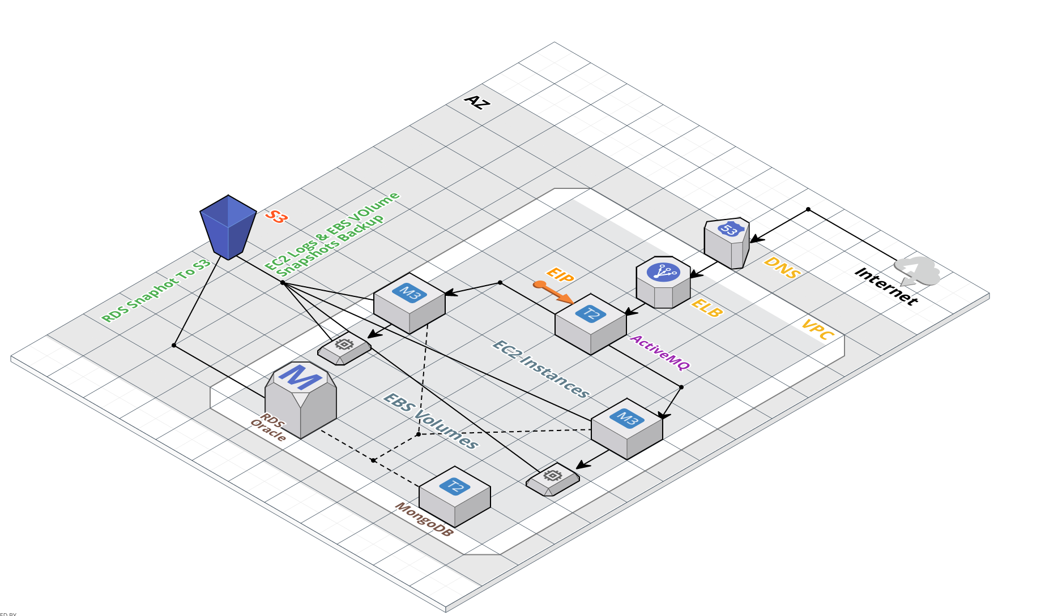

I will explain the architecture in top to bottom approach.

Route 53/DNS:- In this project will use Route 53 for serve client request to our application server. We use Route 53 because it’ is used for domain registration and route users internet requests to application server- it is hosted on AWS EC2.Route 53 have power to route user’s requests to backend instance using routing policies and according to health checks.

VPC:- A "Virtual Private Cloud" is a sub-cloud inside the AWS public cloud. Sub-cloud means it is inside an isolated logical network. Other servers can't see instances that are inside a VPC. It is like a vlan AWS infrastructure inside a vlan.

ELB:- ELB is used for load balancing and transfer the traffic to backend instance. It has the feature to check the health of the backend instance, according to the instance health it will transfer the request to backend instance.

EC2:- EC2 is stands for Elastic Cloud Compute, We launched EC2 instances for NAT machine, application instances and Database.
In our EC2 insance we have setup ActiveMQ server as well as Apache webserver:
ActiveMQ: It is an open-source, messaging software which can serve as the backbone for an architecture of distributed applications built upon messaging. It's used to reliably communicate between two distributed processes. Yes you could store messages in a database to communicate between to processes, but as soon as the message is received you'd have to delete the message.
Apache: We have setup Apache as our web server to serve the files that form Web pages to users, in response to their requests, which are forwarded by their computers' HTTP clients.

Tomcat: Now we have 2 EC2 instances which are serving as application servers in the backend. Tomcat is an application server from the Apache Software Foundation that executes Java servlets and renders Web pages that include Java Server Page coding.

MongoDB: MongoDB server is an open-source, document database designed for ease of development and scaling.

EBS:- EBS volumes have redundancy built in, which means that they will not fail if an individual drive fails or some other single failure occurs. But they are not as redundant as S3 storage, which replicates data into multiple availability zones; an EBS volume lives entirely in one availability zone. This means that making snapshot backups, which are stored in S3, is important for long-term data safeguarding.

RDS:- Amazon Relational Database Service (Amazon RDS) is a web service that makes it easier to set up, operate, and scale a relational database in the cloud. It provides cost-efficient, resizeable capacity for an industry-standard relational database and manages common database administration tasks. Oracle Database is a relational database management system developed by Oracle.

S3: Amazon Simple Storage Service (Amazon S3) is object storage with a simple web service interface to store and retrieve any amount of data from anywhere on the web. It is designed to deliver 99.999999999% durability. We have used S3 for taking backups of EC2 logs, EBS Snapshot backups, RDS snapshot backups.

Glacier: It is a secure, durable, and extremely low-cost cloud storage service for data archiving and long-term backup. We can reliably store large or small amounts of data for as little as $0.007 per gigabyte per month, a significant savings compared to on-premises solutions

